Vson cup connection steps

Step 1

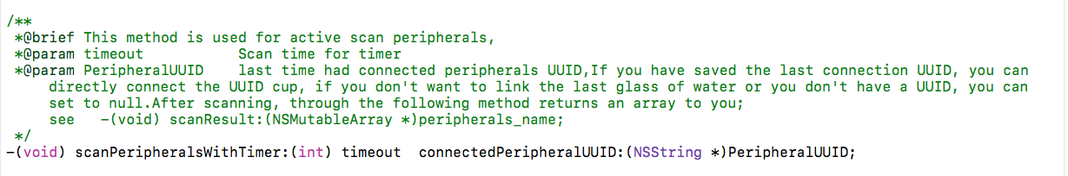

Step 2
After scan ，you will get an array
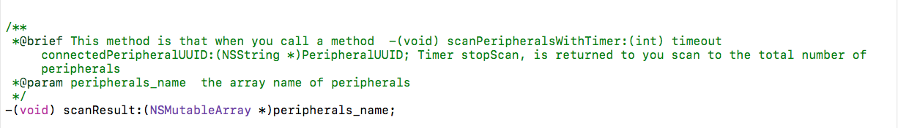

In the callback method, please choose the Cup you want to connect, use this method:
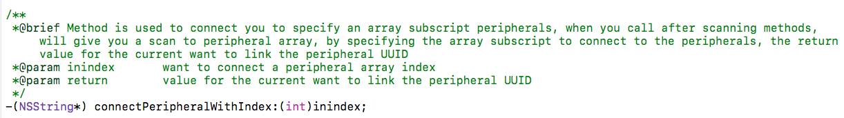

Step 3
Once the connection is successful, there will be two callback method is invoked
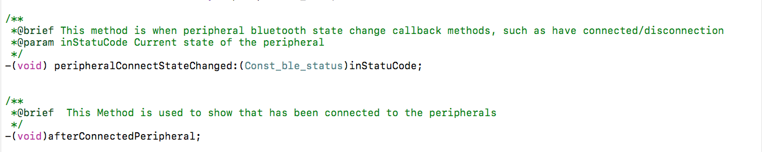

Step 4
After connected to the Cup, as long as the Cup produced drink water data, will pass through the following way：

